# ### 1. s1s2 trans count (within & between PI), succession broad

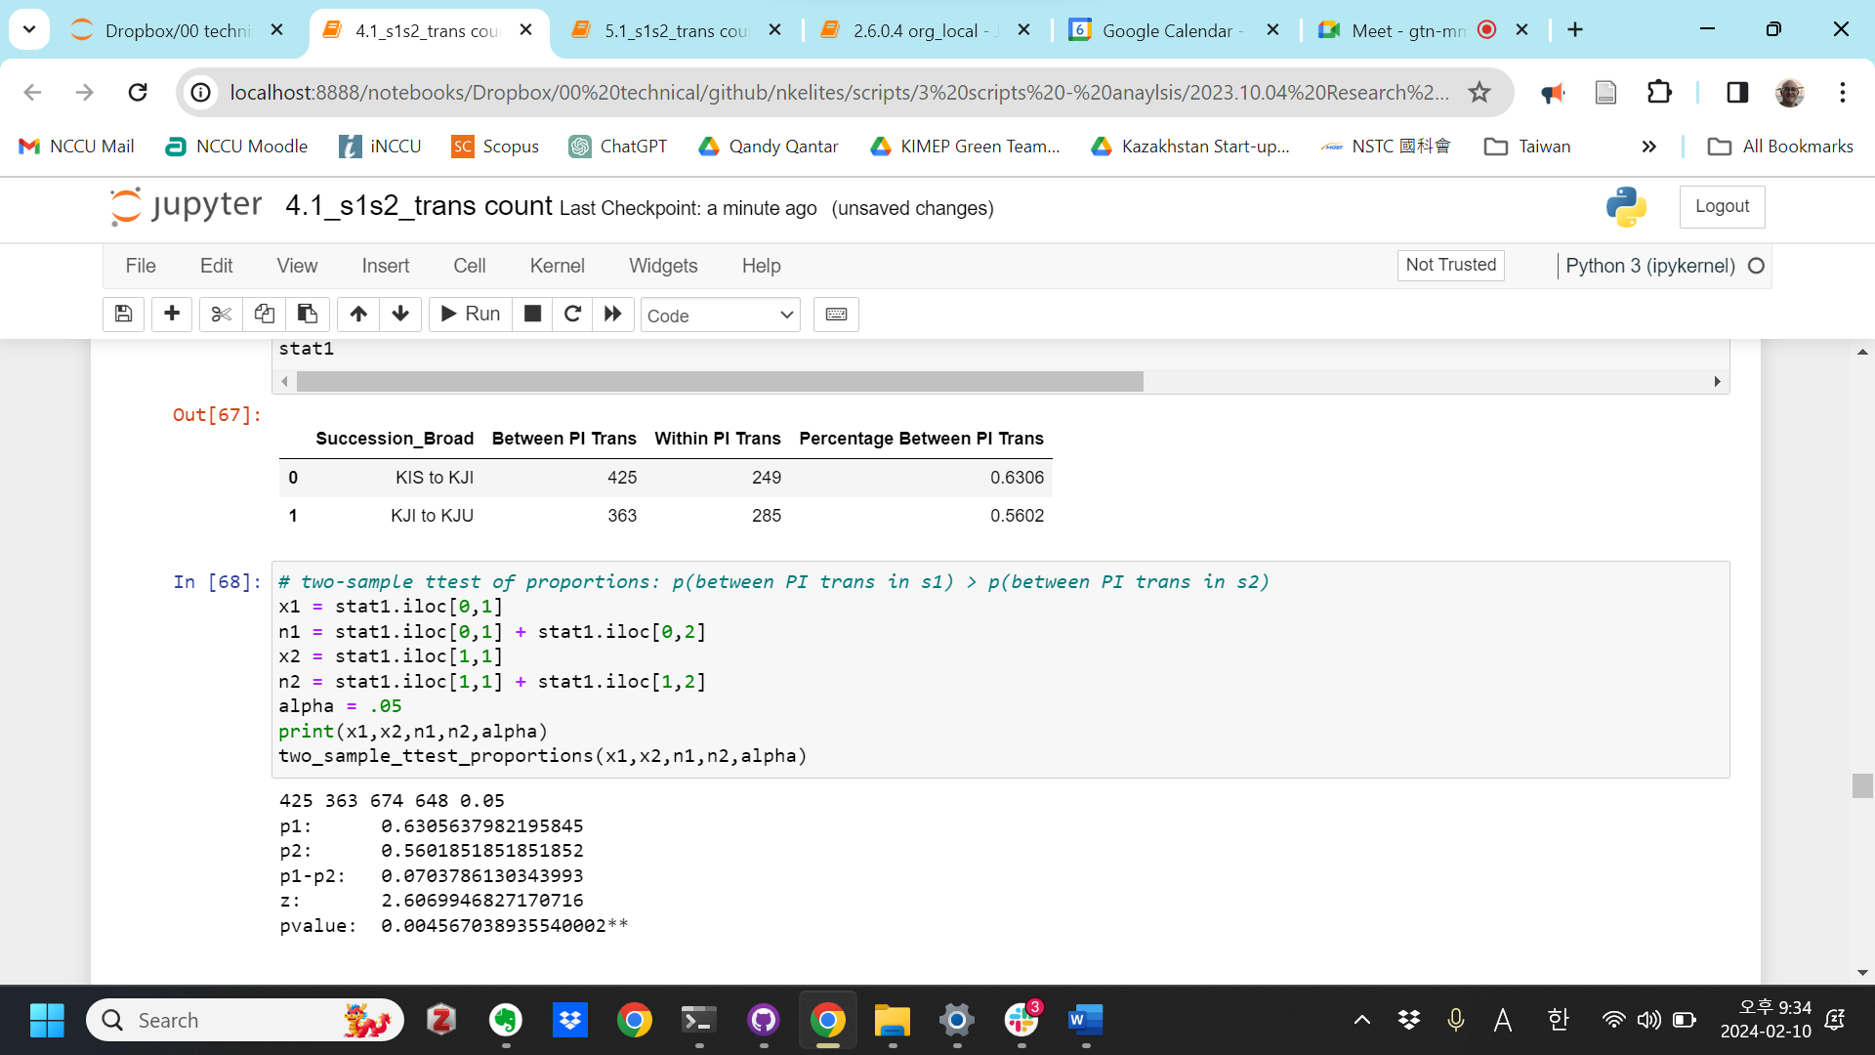

# ### 2. s1s2 trans count (within & between PI), succession narrow

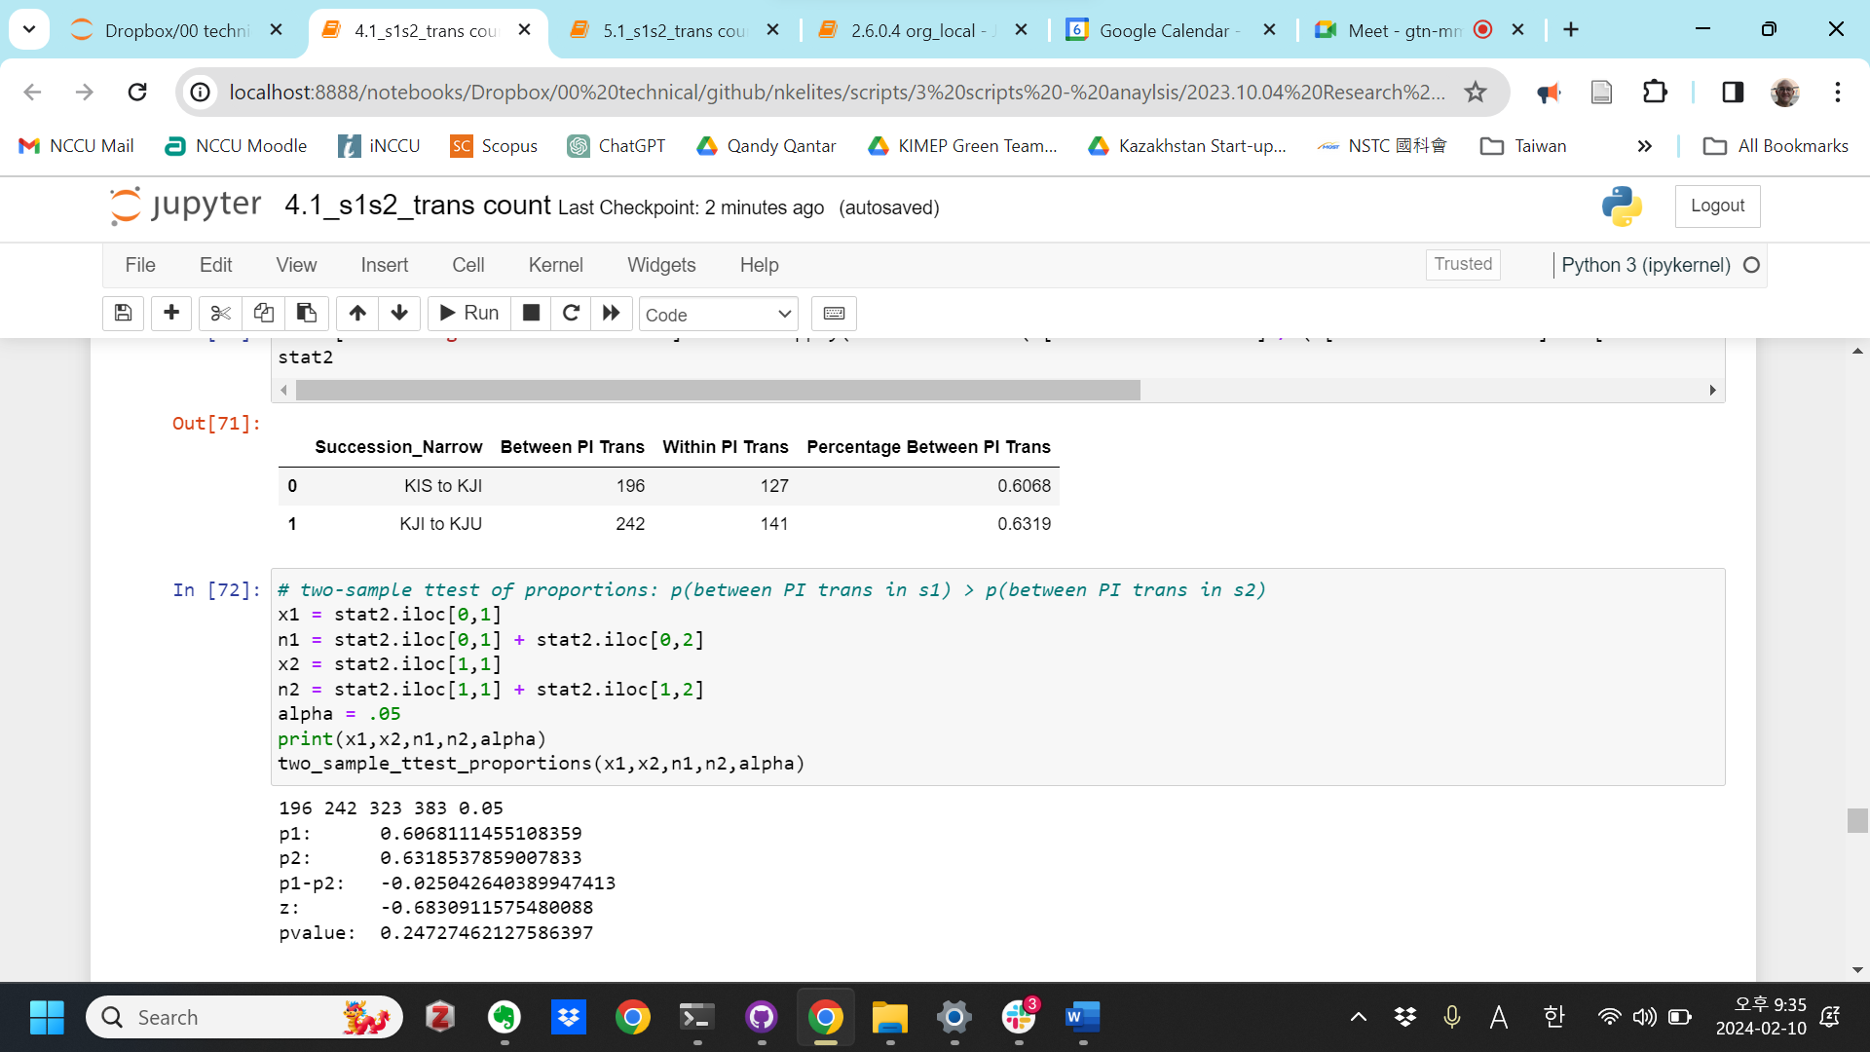

# ### 3. s1s2 trans count (within & between PI), succession broad, by sending PI

Government

175 120 265 289 0.05

p1: 0.660377358490566

p2: 0.41522491349480967

p1-p2: 0.24515244499575634

z: 5.776996170646588

pvalue: 3.8023008075427356e-09***

Social

132 133 144 146 0.05

p1: 0.9166666666666666

p2: 0.910958904109589

p1-p2: 0.005707762557077611

z: 0.17315284424354763

pvalue: 0.4312656442570164

Party

74 28 217 124 0.05

p1: 0.34101382488479265

p2: 0.22580645161290322

p1-p2: 0.11520737327188943

z: 2.235111213838738

pvalue: 0.012705024181294933*

Military

44 82 48 89 0.05

p1: 0.9166666666666666

p2: 0.9213483146067416

p1-p2: -0.004681647940074973

z: -0.09620398060589609

pvalue: 0.46167928470764663

# ### 4. s1s2 trans count (within & between PI), succession narrow, by sending PI

Government

77 79 133 130 0.05

p1: 0.5789473684210527

p2: 0.6076923076923076

p1-p2: -0.028744939271254988

z: -0.4744413995109552

pvalue: 0.3175925884139059

Social

68 71 71 72 0.05

p1: 0.9577464788732394

p2: 0.9861111111111112

p1-p2: -0.02836463223787178

z: -1.028497410534081

pvalue: 0.15185795413987369

Party

38 18 104 103 0.05

p1: 0.36538461538461536

p2: 0.17475728155339806

p1-p2: 0.1906273338312173

z: 3.0869041266057793

pvalue: 0.0010112640850469257**

Military

13 74 15 78 0.05

p1: 0.8666666666666667

p2: 0.9487179487179487

p1-p2: -0.08205128205128198

z: -1.1846349051637255

pvalue: 0.11808091496140638

# ### 5. s1s2 trans count (within & between PI), succession broad, by receiving PI

Government

171 107 261 276 0.05

p1: 0.6551724137931034

p2: 0.38768115942028986

p1-p2: 0.26749125437281357

z: 6.200107861806762

pvalue: 2.821224365234798e-10***

Social

37 39 49 52 0.05

p1: 0.7551020408163265

p2: 0.75

p1-p2: 0.005102040816326481

z: 0.059378268184122555

pvalue: 0.47632541099482384

Party

201 195 344 291 0.05

p1: 0.5843023255813954

p2: 0.6701030927835051

p1-p2: -0.08580076720210972

z: -2.2236027689395153

pvalue: 0.013087591051327951*

Military

16 22 20 29 0.05

p1: 0.8

p2: 0.7586206896551724

p1-p2: 0.04137931034482767

z: 0.3411985242228634

pvalue: 0.3664770670999453

# ### 6. s1s2 trans count (within & between PI), succession narrow, by receiving PI

Government

92 46 148 97 0.05

p1: 0.6216216216216216

p2: 0.4742268041237113

p1-p2: 0.14739481749791028

z: 2.274838389522843

pvalue: 0.011457813185327792*

Social

19 9 22 10 0.05

p1: 0.8636363636363636

p2: 0.9

p1-p2: -0.036363636363636376

z: -0.28829998806257895

pvalue: 0.38655855814547635

Party

67 173 133 258 0.05

p1: 0.5037593984962406

p2: 0.6705426356589147

p1-p2: -0.16678323716267407

z: -3.2090933948882228

pvalue: 0.0006657711611772754***

Military

18 14 20 18 0.05

p1: 0.9

p2: 0.7777777777777778

p1-p2: 0.12222222222222223

z: 1.031674295430419

pvalue: 0.15111236144659512